Satellite-to-Ground Continuous Variable Quantum Key Distribution: The Gaussian and Discrete Modulated Protocols in Low Earth Orbit
Mikhael T. Sayat, Biveen Shajilal, Sebastian P. Kish, Syed M. Assad, Thomas Symul, Ping Koy Lam, Nicholas J. Rattenbury, and John E. Cater

Abstract— The Gaussian modulated continuous variable quantum key distribution (GM-CVQKD) protocol is known to maximise the mutual information between two parties during quantum key distribution (QKD). An alternative modulation scheme is the discrete modulated CVQKD (DM-CVQKD) pro- tocol. In this paper, we perform a feasibility study for practical satellite-to-ground CVQKD with a focus on comparing existing GM-CVQKD and DM-CVQKD protocols with the application of the performance of recent reconciliation methods. We use a satellite-to-ground link model which takes into account geomet- ric, scintillation, and scattering losses from the link distance, atmospheric turbulence, and atmospheric aerosols, respectively. In addition, recent multidimensional (MD) and multilevel coding and multistage decoding (MLC-MSD) reconciliation method models in combination with multiedge-type low-density parity- check (MET-LDPC) code models have been used to determine the reconciliation efficiency. Realistic parameters have been used for the calculation of the secret key rate (SKR) along with a comparison between MD and MLC-MSD reconciliation during satellite-to-ground GM-CVQKD, for the first time. The results show that GM-CVQKD outperforms DM-CVQKD. In addition, GM-CVQKD with MD reconciliation outperforms GM-CVQKD with MLC-MSD reconciliation in the finite size limit by producing positive SKRs at larger link distances and lower elevation angles.
Index Terms— Quantum key distribution, continuous variable, Gaussian modulation, discrete modulation, satellite communica- tion, quantum communication.
- Introduction
Q
UANTUM key distribution (QKD) [1] is a method of sharing a secret key between two parties, Alice and Bob,
Manuscript received 11 May 2023; revised 26 November 2023 and
17 January 2024; accepted 18 January 2024. Date of publication 29 January 2024; date of current version 18 June 2024. University of Auckland Doctoral Scholarship, for which Mikhael T. Sayat is a recipient. The associate editor coordinating the review of this article and approving it for publication was
A. S. Cacciapuoti. (Corresponding author: Mikhael T. Sayat.)
Mikhael T. Sayat is with the Department of Physics, The Univer- sity of Auckland, Auckland 1010, New Zealand (e-mail: msay024@ aucklanduni.ac.nz).
Biveen Shajilal is with the Quantum Innovation Centre, Agency for Science Technology and Research, Singapore 138632.
Sebastian P. Kish is with CSIRO Data61, Marsfield, NSW 2122, Australia. Syed M. Assad and Ping Koy Lam are with the Quantum Innovation Centre, Agency for Science Technology and Research, Singapore 138632, and also with the Department of Quantum Science and Technology, Research School of Physics, The Australian National University, Canberra, ACT 2601, Australia. Thomas Symul is with QuintessenceLabs, Canberra, ACT 2609, Australia.
Nicholas J. Rattenbury is with the Department of Physics, The University of Auckland, Auckland 1010, New Zealand.
John E. Cater is with the Department of Mechanical Engineering, University of Canterbury, Christchurch 8041, New Zealand.
Color versions of one or more figures in this article are available at https://doi.org/10.1109/TCOMM.2024.3359295.
Digital Object Identifier 10.1109/TCOMM.2024.3359295
where eavesdropping by Eve can be inferred as a consequence of fundamental quantum mechanics. The most significant advancement of QKD in space-based applications was the demonstration of discrete variable QKD (DVQKD), which uses the available degrees of freedom of single photons, to encode a key between optical ground stations on Earth and the Micius satellite [2]. Despite its successful deployment in space, its use of expensive and inefficient single photon detectors for detection poses challenges for its popularisa- tion and commercialisation [3]. An appealing alternative is continuous variable QKD (CVQKD) which uses multi-photon technologies to encode the key in the continuous X and P quadratures of light [3], [4]. Its use of homodyne or heterodyne detection is more cost-effective, more compatible with stan- dard telecommunication optical networks, and more efficient, offering higher secret key rates (SKRs) [3], [5], [6].
CVQKD experiments have predominantly been restricted to fibre-based systems in the laboratory where a SKR of
14.2 Mbit/s over 15 km of optical fibre has been demon- strated using a local oscillator [7]. The first demonstration of fibre-based CVQKD over 100 km was performed by control- ling and suppressing excess noise [8]. A SKR of 2.1 Gbit/s in free-space has been achieved using 10-channel wavelength division multiplexing in the weak turbulence regime [9] using the Kramers-Kronig scheme which digitally separates the quadrature components [10], and a SKR greater than
1.68 Gbit/s can be reached in a lossless and excess noise free system that uses two polarisations, six wavelengths, and four orbital angular momentum for multiplexing [11]. In addition, an average SKR of 1.015 Mbit/s was achieved over a turbulent 1 m free-space channel with a transmittance between 6 dB to 15 dB using the passive-state-preparation CVQKD protocol, which has the same security proof as GM-CVQKD assuming Alice’s transmitter is trusted [12]. A study of atmospheric effects on quantum communications over 1.6 km of free-space was performed and the experimental setup was capable of CVQKD [13]. However, there has only been one demonstration of free-space CVQKD which occurred over 460 m in an urban environment and achieved a SKR of
− −
0.152 kbit/s using unidimensional Stokes operator encoding by modulating the quantum Stokes parameter with a Gaussian distribution [14]. It should be noted that the Kramers-Kronig scheme and Stokes operator encoding do not provide uncon- ditional security, unlike GM-CVQKD [3].
The two modulation approaches for CVQKD to encode a key are Gaussian modulation (GM-CVQKD) [3] and

0090-6778 © 2024 IEEE. Personal use is permitted, but republication/redistribution requires IEEE permission.
See https://www.ieee.org/publications/rights/index.html for more information.

discrete modulation (DM-CVQKD) [15], where implemen- tations can be found in associated publications, [16], [17]. The GM-CVQKD protocol is capable of achieving higher SKRs as the coherent state distribution follows a continuous Gaussian distribution allowing for more positions on the optical phase space [3]. In contrast, DM-CVQKD positions a finite number of coherent states on the optical phase space, limiting its achievable SKR [18], [19], [20]. Under ideal circumstances of perfect CVQKD and channel parameters, GM-CVQKD produces larger SKRs. However, it is not evident that DM-CVQKD performs better under realistic non-ideal parameters. In fact, DM-CVQKD was proposed to address the poor performance of CVQKD in the low SNR regimes [15]. Since the coherent states on the optical phase space follow a discretised distribution, it may be argued that the states are more distinguishable and can accommodate more excess noise.
Previous studies on satellite-to-ground CVQKD provide a variety of models for the laser propagation between a satellite and an optical ground station (OGS) [21], [22], [23], [24], [25]. However, there are no published comparisons between existing GM-CVQKD and DM-CVQKD protocols with the application of the performance of existing reconciliation methods for CVQKD in a satellite-to-ground context. In this work, the feasibility of practical low Earth orbit (LEO - orbit altitudes of 160-1000 km) satellite-to-ground GM-CVQKD and DM-CVQKD are investigated. These protocols are also com-
pared in the asymptotic and finite size limits, using realistic
TABLE I
Excess Noise in Daylight [31]. The Values Are Normalised to
Shot Noise and Are Expressed in Shot Noise Units (SNU)

- GM-CVQKD
In GM-CVQKD [3], Alice sends a series of displaced coherent states,
|α⟩ = |q + ip⟩, (1)
where q and p are the amplitude and phase quadrature components. These are both random variables of the same zero-centred normal distribution:
q, p = N(0, V_{A}). (2)
Here, V_{A} is the modulation variance. The covariance matrix describing the Gaussian modulated coherent state sent from Alice to Bob is
γAB
)
(
A
,
T
VA

parameters to calculate accessible SKRs. The DM-CVQKD
protocols studied are the
M
-PSK protocol that assume
= √
(V_{A} + 1)I √T (V ² + 2V_{A})σ_{z}
(
2 + 2
V_{A} σ_{z} T
VA + 1 + χline
)I
(3)

Gaussian optimality under collective attacks [15], [18], [19], [20], [26], [27], and the M -QAM protocol which does not assume Gaussian optimality under collective attacks [28]. The calculated achievable asymptotic limit SKRs are compared
where V_{A} is the modulation variance of Alice, T is the overall transmittance between Alice and Bob, and χ_{line} is the noise in the channel line expressed in shot noise units. I and σ_{z}
are the identity matrix, 1 0 , and the Pauli matrix, 1 0 ,

to the known SKR upper bound in a satellite-to-ground context [29], [30]. In addition, the performance of recent
0 1
respectively.
0 −1

multidimensional (MD) reconciliation and multilevel coding and multistage decoding (MLC-MSD) reconciliation methods are applied to the GM-CVQKD protocol for the calculation of finite size limit SKRs in a satellite-to-ground context.
The work is structured as follows. Section II introduces the GM-CVQKD protocol as well as the M -PSK and M -QAM DM-CVQKD protocol. Section III describes the process used when considering finite size effects. Section IV introduces the LEO satellite to OGS link model. Section V discusses the
The asymptotic limit SKR [bits/pulse] is calculated as
SKR_{asy} = βI_{AB} − S_{BE}, (4)
where β is the reconciliation efficiency, I_{AB} is the mutual information between Alice and Bob, and S_{BE} upper bounds the Holevo information that represents the maximum mutual information between Eve and Bob in the protocol [15]. The mutual information for homodyne and heterodyne detection are calculated as

achievable SKRs of LEO satellite-to-ground GM-CVQKD and DM-CVQKD, and the resulting trends in SKR from parameter
,
variation. Section VI discusses aspects of the feasibility study
1
IAB,hom = 2 log2
(
(V_{A} + 1) + χ_{tot}

1 + χ_{tot}

for real world satellite-to-ground CVQKD, and Section VII presents the conclusions.
—
IAB,het
= log₂
V_{A} + 1) + χ_{tot}
, (5)
1 + χ
tot

- THE GM-CVQKD AND DM-CVQKD PROTOCOLS
In this section, the GM-CVQKD protocol and the M -PSK
where the total excess noise, χ_{tot}, combines both the channel noise, χ_{line} = ¹ 1 + ϵ_{ch} (where ϵ_{ch} is the channel excess noise (Table I)), and detection excess noise, χ_{hom/het}, and is

DM-CVQKD protocol with security under collective attacks
T
T
expressed as χ_{tot}
= χline
+ ^{χ}hom/het [19]. The detection noise

and assuming Gaussian optimality are investigated. The
is different for homodyne and heterodyne detection where

M -QAM DM-CVQKD protocol with security under collec-
η
η
χhom = (1−η)+ϵ_{det}
and χ_{het} = ^{1+(1−η)+2ϵ}det , respectively.

tive attacks without assuming Gaussian optimality is also studied.
Here, η is the detector efficiency and ϵ_{det} is the detector excess noise (Table I).

The Holevo information is calculated as
S = G λ₁ − 1 + G λ₂ − 1
BE
2
2
−G λ3 − 1 − G λ4 − 1 , (6)
2
2

where G(x) = (x + 1) log₂(x + 1) x log₂ x and λ are the symplectic eigenvalues of the covariance matrix, γ_{AB}. λ_{1,2} is calculated as
—
= r 1 ( √ 4 ) (7)

Fig. 1. Constellation diagrams of the 2,4,8-PSK protocols on the optical phase space. The coherent states have been modulated with a constant α and have equal probability. x = amplitude quadrature, p = phase quadrature.

where
λ1,2
2 A ±
A2 − B ,

with security under collective attacks, has the same form as the Gaussian modulation scheme [19],

A = (V_{A} + 1)² + T ²(V_{A} + 1 + χ_{line})² − 2TZ², and √
2 2
(V_{A} + 1)I
TZ_{M} σ_{z}
B = (T (V_{A} + 1)
2
+ T (V_{A} + 1)χ_{line} − TZ
) . (8)
γ_{AB} =
√TZ_{M}
σ_{z}
T (V
A
+ 1 + χ_{line}
)I
. (12)

λ_{3,4} is calculated as

λ3,4 =

r 1 (C ±

√C2 − 4D), (9)
In this case, the correlation coefficient, Z_{M} , varies between each M -PSK protocol:
- Z2 = α2(ζ3/2ζ−1/2 + ζ3/2ζ−1/2),
- Z₄ = 2α Σ
0
1
1
0

where
2

Aχ + (V

+ 1)√B + T (V

+ 1 + χ )
2 3
k=0
- Z₈ = 2α Σ
2 7
k=0
(ζ3/2 ζ−1/2),
k−1 k
(ζ3/2 ζ−1/2).
k−1 k

Chom =
hom A
A line ,
The parameter ζ_{k} varies for each M -PSK protocol:

T (VA + 1 + χtot) 2-PSK protocol:

√V + 1 + √Bχ
2
2
ζ = e^{−α} cosh α²,

D_{hom} = B ^{A}
hom , (10) • 0 −α 2

T (V_{A} + 1 + χ_{tot})
- ζ₁ = e sinh α .

for homodyne detection, and
- PSK protocol:

1 −α 2 2
2

ζ_{0,2} = e
- 2
2 2
(cosh α
2
± cos α ),

Aχhet + B + 1 + 2TZ
- ζ_{1,3} = ¹ e^{−α} (sinh α² ± sin α²).

Chet =
[T (V_{A}
+ 1 + χ_{tot}
√
)]2 ,
2
8-PSK protocol:

2χ_{het}[(V_{A} + 1) B + T (V_{A} + 1 + χ_{line})]
ζ = ¹ e^{−α}2 (cosh α² + cos α² ± 2 cos ^{α}2 cosh ^{α}2 ),

+ [T (V
+ 1 + χ
)]2 ,
- 0,4 4
√ √2 √2

A tot
ζ = ¹ e^{−α}2 (sinh α² + sin α² ±
2 cos ^{α}2 sinh ^{α}2 ±

V + 1 +
√Bχ !2
- 1,5 4
α2 α2
√
√2 √2

Dhet =
A het
T (V_{A} + 1 + χ_{tot})
(11)
2 sin √2 cosh √2 ),
ζ = ¹ e^{−α}2 (cosh α² − cos α² ± 2 sin ^{α}2 sinh ^{α}2 ),

- 2,6 4
√ √2 √2

√ ζ = ¹ e^{−α}2 (sinh α² − sin α² ∓
for heterodyne detection. Here, Z =
V ² + 2V_{A} for
•
3,7
4
√2
√2
A
√2 sin ^{α}2 cosh ^{α}2 ),

2 cos ^{α}2 sinh ^{α}2 ±

√2 √2
Gaussian modulation.
where α = q VA .
2

- M-PSK DM-CVQKD
In the 2-PSK protocol, Alice sends one of two coherent states with equal probability (0.5). In the 4-PSK protocol, Alice sends one of four coherent states with equal probability (0.25). In the 8-PSK protocol, Alice sends one of eight coher- ent states with equal probability (0.125). This is summarised below [18]:
  - S₂ = {|α⟩, |αe^{iπ}⟩}
  - S₄ = {|α⟩, |αe^{iπ/2}⟩, |αe^{iπ}⟩, |αe^{i3π/2}⟩}
  - S₈ = {|α⟩, |αe^{iπ/4}⟩, |αe^{iπ/2}⟩, |αe^{i3π/4}⟩,
|αe^{iπ}⟩, |αe^{i5π/4}⟩, |αe^{i3π/2}⟩, |αe^{i7π/8}⟩}
The M -PSK (M = 2, 4, 8) protocols use coherent states with a magnitude α, and are represented in the optical phase space as shown in Figure 1.
The DM-CVQKD covariance matrix which describes the discretely modulated coherent state sent from Alice to Bob,
The asymptotic limit SKR is calculated as shown in Equations 4-11. However, Z_{M} is used for the Z term.

- M-QAM
In [28], a security proof for the M -PSK and M -QAM DM-CVQKD protocols without Gaussian optimality under collective attacks from an eavesdropper in the asymptotic limit was developed. Unfortunately, using the security proof with the transmittances and excess noise in a typical satellite-to- ground link (Table I), M -PSK is not capable of producing a positive SKR. A more attractive protocol is M -QAM as it produces positive SKRs at lower transmittances and higher levels of excess noise. In M -QAM, M coherent states are modulated to be distributed equidistantly with each other on the optical phase space. By assigning a non-uniform prob- ability to each coherent state, M -QAM can be tailored to a

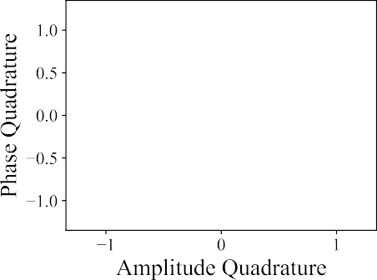
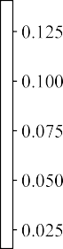
discretised Gaussian distribution to further increase the mutual information between Alice and Bob.
The modulated coherent state is described as

α√2 αk,l = √m − 1

- m − 1
2
—
α√2
+ i √m − 1
- m − 1 ,
2
—

(13)
where M = m² a√n d the cohere√nt states are equidistantly
spaced between − m − 1 and m − 1 in the phase and
amplitude quadratures. Here, k = l = 0, 1, . . . , (m 1). The probability of each coherent state, p_{k,l}, can follow either a binomial distribution,
—
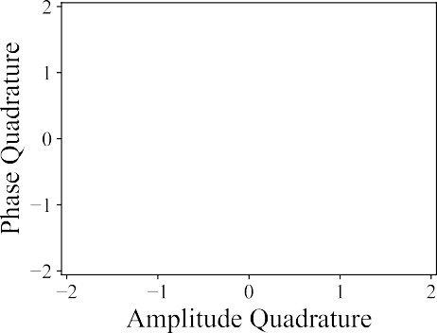
p = 1 m − 1 m − 1 , (14)
k,l
22(m−1)
k
l
or a discrete Gaussian distribution,
p_{k,l} ∼ exp(−v x² + p² ), (15)

where x =
2
2
Here,
α√2
√m−1
k − m−1 and p =
α√2
√m−1
l − m−1 .

v is a free parameter which is optimised to maximise the SKR. For example, Figure 2 shows 16-QAM, 64-QAM, and 256-QAM on the optical phase space with the probability of each modulated coherent state based on the binomial distribution. It can be seen that a greater number of coherent states better approximates the Gaussian distribution.
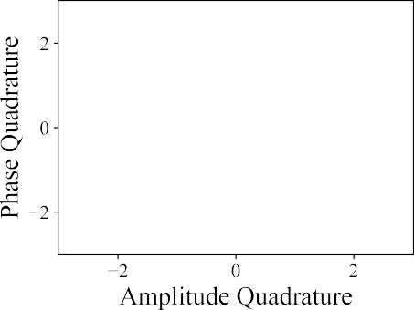
The asymptotic limit SKR is calculated as in Equation 4. However, the mutual information is calculated as
  - TV_{A}
I_{AB,hom} = 2 log₂ (1 + 2 + Tϵ ),

IAB,het
= log₂
(1 + TVA ). (16)
2 + Tϵ

The Holevo information is determined from the covariance matrix given by,
=

Γ∗AB
(V_{A} + 1) I Z∗σ_{z}
Z∗σ_{z} (1 + TV_{A} + Tϵ) I
. (17)

The Holevo information is therefore,
S = G λ1 − 1 + G λ2 − 1 − G λ3 − 1 , (18)
BE
2
2
2
Fig. 2. M -QAM with probabilities based on the binomial distribution.
(a) 16-QAM (b) 64-QAM (c) 256-QAM.

where λ₁ and λ₂ are the symplectic eigenvalues of the covari- ance matrix, Γ∗AB . The symplectic eigenvalue, λ₃, is calculated

w is defined as

as s w = Σ p_{k} |α_{k}⟩ aˆ† aˆ_{τ} |α_{k}⟩ − |⟨α_{k}| aˆ_{τ} |α_{k}⟩|2 . (22)
τ

λ3,hom =
+ 1 − 1 + TV
(V_{A} + 1)
Z∗2
V_{A}
A
Z∗2
+ Tϵ
, and
k
Although M -QAM is a DM-CVQKD protocol, the assign- ment of a probability following a Gaussian distribution to each

λ_{3,het} = V_{A} + 1 − 2 + TV + Tϵ, (19)
A
for homodyne and heterodyne detection, respectively. For an arbitrary modulation, the lower bound of the correlation coefficient, Z∗, can be calculated as
Z∗(T, ϵ) = 2√T Tr( 1 ˆ 1 aˆ†) − √
modulated coherent state raises the question of whether or not it loses its DM-CVQKD features, especially when M is large. In particular, the distinguishability of the coherent states on the optical phase space. In addition, the calculation of SKRs in the finite size limit for M -QAM remains an open question [28]. As a result, only the SKRs in the asymptotic limit will be

τ 2 aτ 2
2T ϵw, (20)
studied in a satellite-to-ground context.

where aˆ and aˆ† are the annihilation and creation operators,
respectively, ϵ is the total excess noise, and τ is the density matrix of the modulation:
Σ
τ = p_{k}|α_{k}⟩⟨α_{k}|. (21)
k

- Finite Size Effects
The SKR calculation (Equation 4-11) is for the idealistic asymptotic limit in which an infinite number of symbols are sent between Alice and Bob, and provides an upper bound

to the achievable SKR. The finite size limit SKR, which represents a realistic case in which a finite number of symbols are sent between Alice and Bob [32], can be calculated as
SKR_{fin} = f (1 − FER)(1 − v)[βI_{AB} − S_{BE} − δn_{privacy}],
(23)
where f is the laser repetition rate, FER is the frame error rate, v is the fraction of symbols excluded for channel parameter estimation, and δn_{privacy} represents the proportion of the key further attributed to information gained by the eavesdropper to reflect the validity of estimated channel parameters in
TABLE II
Coefficients of β

The coefficients, c_{i}, for β are displayed in Table II. The calculation of the FER uses the coefficients m₁ = 0.8218, m₂ = −19.46, and m₃ = −298.1 as shown in Equation 26.
βMLC−MSD/MD = cc2SNR − cc4SNR,

determining the Holevo information. However, to account ¹ ³
1

for high error rate error correcting codes in long-distance CVQKD, the finite size limit SKR must be amended to [33], [34]:
FER = 2 (1 + m₁ arctan(m₂SNR + m₃)). (26)
The SNR is calculated as

SKR_{fin} = f [(1 − FER)βI_{AB} − S_{BE} − δn_{privacy}]. (24)
SNR = 10 log₁₀
T |α|2
|α|2 + (1 − T )χ_{tot}
,
(27)

It should be noted that the term (1 v) has been excluded as shown in composable security proofs where Alice can estimate channel parameters after error correction [35], [36]. Here, δn_{privacy} is calculated as
—
ϵs
and depends on α, transmittance (T ) and excess noise (χ_{tot}) between Alice and Bob. Note that β_{MLC−MSD}, β_{MD}, and FER in Equation 26 are only valid when they have a value between 0 and 1.

(d + 1)2
4(d + 1)qlog₂( ² )
- Satellite-to-Ground Channel Model

δnprivacy =
√N +
  - log ( ² )
2
+ ϵ²ϵs
√
N
√N
4√ϵs d
ϵ
+ ^{N} , (25)
√
N
Clouds, atmospheric turbulence, and atmospheric aerosols are the three main sources of signal degradation in the atmo- sphere that cause the transmittance of the signal to decrease through attenuation. The model developed considers the fol-

where d is a discretisation parameter, ϵ_{s} is a smoothing param- eter, ϵ is a security parameter representing the probability that the key is not secret, and N is the total number of symbols sent between Alice and Bob, the details of which can be found in previous work [31], [37], [38], [39]. Previous experimental CVQKD demonstrations have used laser repe- tition rates between 10 and 500 MHz [40], [41], [42], [43]. A laser repetition rate of f = 50 MHz has been chosen for the calculation of finite size limit SKRs, which is near the lower end of the range of laser repetition rates used in successfully demonstrated CVQKD, to show modest and more achievable finite size limit SKRs.
Reconciliation methods can be split into Multidimensional (MD) reconciliation and Multilevel Coding and Multistage Decoding (MLC-MSD) reconciliation [32]. MLC-MSD recon- ciliation is generally employed for CVQKD at SNRs greater than 0 dB, while MD reconciliation is employed for CVQKD at SNRs less than 0 dB. Low-density parity-check (LDPC) codes can be used with MD and MLC-MSD reconciliation. Multiedge-type LDPC (MET-LDPC) codes are regarded as suitable for both MD and MLC-MSD reconciliation. Recent practical MD reconciliation efficiencies and FERs asymptoti- cally approach 100% as the SNR decreases [32].
The dependency of β and FER on the SNR in (Equation 26) have been empirically determined from [32], and are used to calculate and analyse the satellite-to-ground SKRs in the finite size limit. The FER equation is for N = 106. However, the general trend shows that the FER decreases as N increases [32]. As a result, a code block length of N = 1011 has been used for finite size limit SKR calculations.
lowing: geometric losses due to the distance between Alice (satellite) and Bob (OGS), the hardware used, scintillation losses due to the atmospheric turbulence, scattering losses due to atmospheric aerosols. Clouds are not included in the model as they effectively destroy the signal and act as a blockage, completely attenuating the signal. The solution to this is accurate cloud coverage analyses and OGS network site diversity [44] to spatiotemporally maximise channel links between Alice and Bob regardless of environmental condi- tions. In addition, weather conditions such as rain, snow, and hail effectively destroy the signal and can cause damage to an OGS telescope [45]. Therefore, in the presence of clouds, rain, snow, and hail, satellite-to-ground CVQKD is not ideal. Atmospheric losses depend on the thickness of the atmosphere or the atmospheric mass the signal propagates through. On average, 95% of the total atmosphere mass is within the first 20 km from ground to zenith [46], [47] and so atmospheric losses can be modelled as approximately
confined to this range.
Figure 3 displays the channel link between the satellite and OGS where the total link distance and effective atmosphere thickness is a function of the elevation angle. The model assumes a uniform atmosphere thickness of 20 km. The total link distance, L_{tot}, and effective atmosphere thickness, L_{atm,eff} , can be calculated as
L_{tot} = ((R_{E} + L_{zen})² + (R_{E} + L_{OGS})²

1
— 2(R_{E} + L_{zen}) (R_{E} + L_{OGS}) cos (α₁)) 2
θ − θ ,
α = arcsin cos ( )(RE + LOGS) + (90 ) and
¹ RE + Lzen

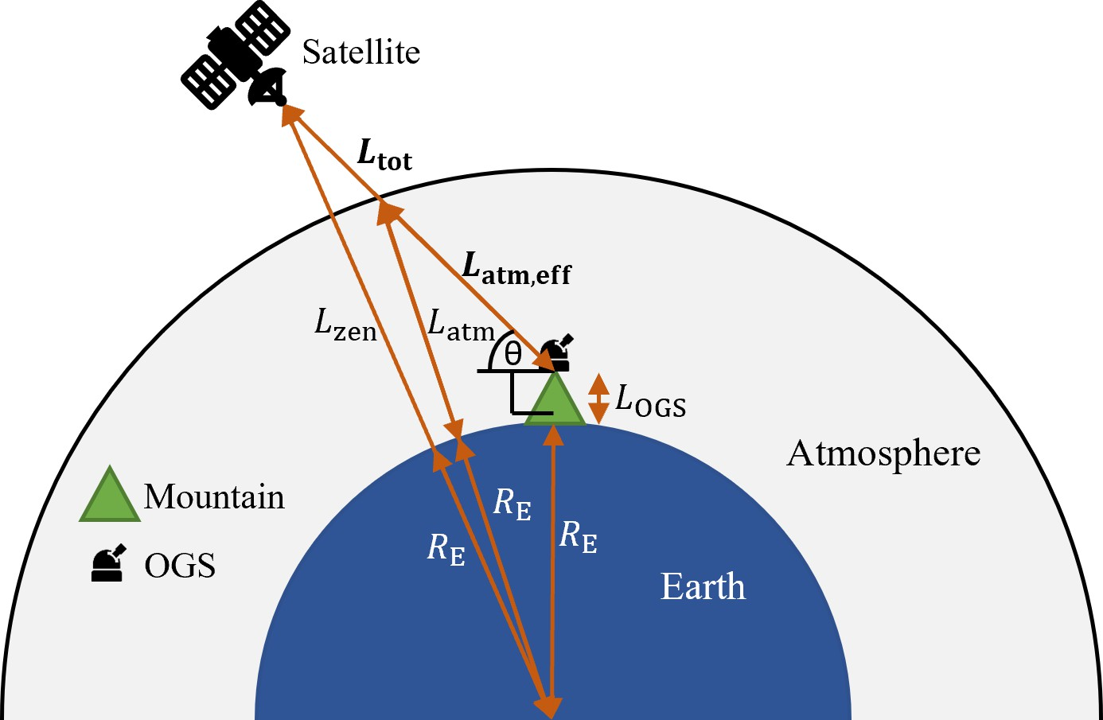
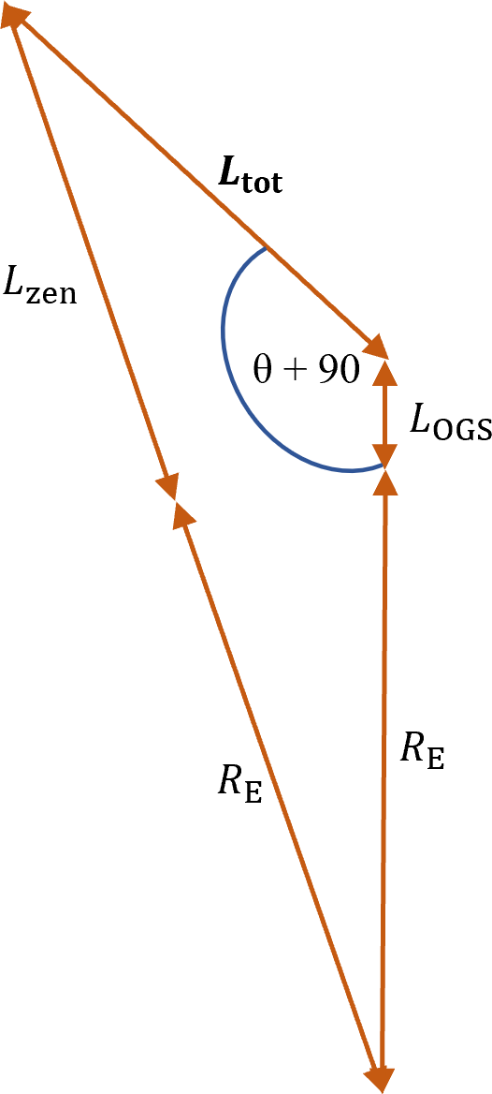
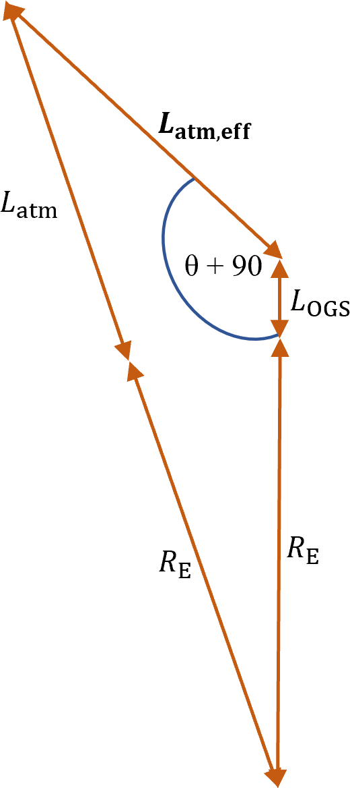
pointing, tracking (APT) system of the OGS as well as beam wandering. Equation 29 assumes that the receiver is in the far field of the transmitter (L_{tot} ^{D}r Dt ), the transmitter is diffraction limited, and there is no attenuation from the atmo- sphere which enables the later addition of other atmospheric losses (scattering and scintillation losses) in the overall model.
λ
≥

B. Scattering Losses
Atmospheric aerosols attenuate the signal through three regimes of scattering [49]: Rayleigh scattering caused by air molecules, Mie scattering caused by haze and fog, and geo- metrical scattering caused by rain, snow etc. For the 1550 nm wavelength used in CVQKD, the effects of Rayleigh scattering on the transmittance are negligible [49], and geometrical scattering effects are neglected as satellite-to-ground CVQKD, in general, is not ideal during weather conditions such as rain, snow, and hail.
The Kruse and Kim model [50] is used to model losses related to Mie scattering. The model depends on the wavelength of the signal and the atmospheric visibility,
V (Equation 30). The resulting loss per kilometre is then mul- tiplied by the effective atmosphere thickness (Equation 28):

A = 10 log
(e)( 3.912 )( λ
)^{−p} [dB/km],

scat
 1.3 6 km ≤ V < 50 km

¹⁰ V 550

Fig. 3. The satellite-to-ground channel model is shown in (a). (b) and (c)
 1.6 V ≥ 50 km

p = 0.16V + 0.34 1 km ≤ V < 6 km
V − 0.5 0.5 km ≤ V < 1 km

0 V < 0.5 km.

(30)

shows the trigonometric determination of the total link distance and effective atmosphere thickness, respectively.

Latm,eff = ((RE + Latm)2 + (RE + LOGS)2

1
— 2(R_{E} + L_{atm})(R_{E} + L_{OGS}) cos (α₂)) 2

(R_{E} + L_{OGS})
α₂ = arcsin
cos (θ)
+ (90 − θ), (28)
R
E
+ Latm
C. Scintillation Losses
Atmospheric turbulence causes refractive index variations in the atmosphere and distorts the optical wavefront of the laser, leading to intensity fluctuations and losses in the received sig- nal observed as speckles on an imaging detector [44]. This is a phenomenon known as scintillation, and it can be quantified by the scintillation index, σ². As the receiver involves a telescope,
I
it is assumed to have an aperture diameter larger than the

where R_{E} is the radius of Earth, L_{OGS} is the altitude of the OGS, L_{zen} is the altitude of the satellite at zenith (90○ elevation angle), L_{atm} is the atmospheric thickness con- taining 95% of atmospheric mass, and θ > 0 is the elevation angle.

A. Geometric Losses
Geometric losses, A_{geo} (in units of decibels), arise from the link distance and optical hardware used in the transmission and reception of the signal, and can be estimated from [48],
L
irradiance correlation width (lateral intensity coherence length) of the speckles. Therefore, aperture averaging is utilised, decreasing the adverse effects of scintillation [51].
The losses related to scintillation with aperture averaging are described in Equation 31 which depends on the scintillation index, σ², and the probability that the received power is below the minimum required power to register a signal, p_{thr}. p_{thr} is equivalent to the fraction of link outage time. Here, it is assumed that the received signal is a spherical wave. The resulting loss as a function of the scintillation index is given by [51],
I

A_{geo} = 10 log₁₀
2 2
tot
λ
1
(1 )
[dB], (29)
A = 4.343
erf⁻¹ (2p
— 1)
1
2 ln(σ² + 1) 2

D²D2 T_{t} − L_{p} T_{r}
t
r
sci
thr I

which depends on the total link distance (L_{tot}), wavelength
R
2
I
(λ), transmitter and receiver aperture diameter (D , D ), trans-
— 1 ln(σ² + 1) [dB]. (31)

mitter and receiver efficiencies (T_{t}, T_{r}), and pointing loss (L_{p}) which is attributed to the inefficiency of the acquisition,
t
r
The scintillation index can be calculated using Equation 32 which depends on the Rytov variance (σ² ), the effective

atmosphere thickness (L_{atm,eff} ), and the refractive index
TABLE III

structure parameter (C²). Here. k = ^{2π}
is the wave number,
CVQKD Link Parameters

π ¹ n λ

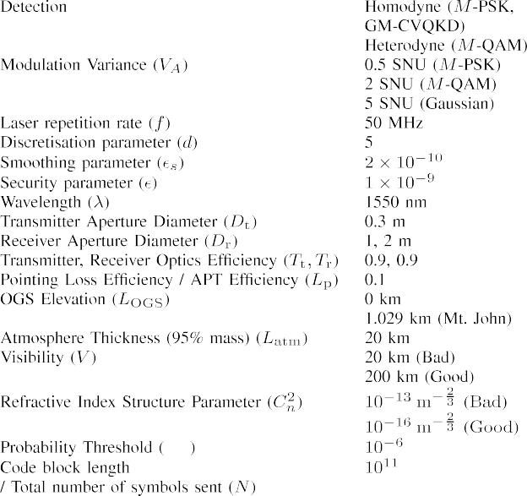
d = Dr( 2λLatm,eff
) 2 , D_{r} is the aperture diameter of the

receiver, and λ is the wavelength.
2( ) = exp 0.20σ2
σI
D_{r}
R
6
7
[1 + 0.18d2 + 0.20(σ² ) 5 ] 6
R
0.21σ² [1 + 0.24(σ² ) 6 ]− 5
∫
5
+
R
R
2
5
2
6
6
— 1,
1 + 0.90d
2
+ 0.21d (σR) 5

² = 2.25
σ
R
7 Latm,eff

k 6
0
C²(z
)(Latm,eff − z
) 6 dz. (32)

The refractive index structure parameter, C² [m⁻ 2 ], defines
n
n 3
the intensity of turbulence in the atmosphere. Although this can be calculated more accurately through models such as the Hufnagel-Valley models [5], [52], C² is set to be a constant parameter, where C² = 10−16 corresponds to low turbulence levels, C² = 10−14 corresponds to medium turbulence levels, and C² = 10−13 corresponds to high turbulence levels [45].
n
n
n
n

- Satellite-to-Ground GM-CVQKD and
DM-CVQKD SKR ANALYSIS
In this section, the SKRs of satellite-to-ground GM- CVQKD and DM-CVQKD are estimated with typical daylight excess noise values (Table I), and the losses applied to the total link distance and effective atmosphere thickness. The total attenuation based on losses is defined as
Atot = Ageo(Ltot) + AscatLatm,eff + Asci(Latm,eff ) [dB]
(33)
and the transmittance is calculated as the non-logarithmic inverse of A_{tot}. Of the three sources of attenuation, geometric loss dominates due to the relatively large distance between the satellite and OGS. In calculating geometric losses, the assumption that the receiver is in the far field of the transmitter is governed by L ^{D}r Dt . In situations where this inequality does not hold, the SKR calculation has been omitted. However, the general trend should still apply.
λ
≥
Several parameters were varied for the analysis of the GM-CVQKD and DM-CVQKD protocols under different satellite orbits (Table III). The two values for the visibility and the refractive index structure parameter correspond to good atmospheric conditions where the visibility is high and there is low atmospheric turbulence (V = 200 km, C² = 10−16), and bad atmospheric conditions where visibility is low and there is high atmospheric turbulence (V = 20 km, C² = 10−13). Two values of the receiver aperture diameter were also used to observe the changes in achievable SKR. The modulation variance for Gaussian and discrete modulation were chosen to be close to optimal (V_{A} = 5 SNU for Gaussian modulation, V_{A} = 0.5 SNU for M -PSK, V_{A} = 2 SNU for M -QAM). The
n
n
SKRs for GM-CVQKD and DM-CVQKD were calculated as a function of the satellite altitude at zenith at different elevation angles (30○, 60○, 90○) in reference to the satellite altitude at zenith.

- Asymptotic Limit SKRs of GM-CVQKD and DM-CVQKD Protocols
This section calculates the asymptotic limit SKRs for satellite-to-ground GM-CVQKD and DM-CVQKD under col- lective attacks from Eve. A reconciliation efficiency of 90% has been used for asymptotic limit SKR calculations. The asymptotic limit SKRs are also compared to the loss-limited SKR upper bound when the satellite is at zenith [29].
The results in Figure 4 show that for a receiver aperture diameter of 1 m and good atmospheric conditions, GM- CVQKD outperforms all DM-CVQKD protocols. The 2-PSK protocol does not produce any positive SKRs and is there- fore unsuitable for satellite-to-ground downlinks. As expected, smaller elevation angles produce smaller SKRs as the signal travels through a larger link distance and effective atmosphere thickness, suffering greater attenuation. The M -QAM protocol outperforms the M -PSK protocol, where M -PSK can only achieve positive SKRs at smaller LEO altitudes. The M -QAM protocol can produce positive SKRs at small medium Earth orbits (MEOs - orbit altitudes of 1000-35,786 km) with the 256-QAM protocol capable of producing positive SKRs at larger link distances.
In bad atmospheric conditions, the M -PSK protocol cannot
produce positive SKRs in LEO. In addition, the SKRs of GM-CVQKD and M -QAM have been significantly decreased (Figure 5).
Figure 4 and Figure 5 show that the asymptotic limit SKRs for GM-CVQKD and DM-CVQKD are well below the loss-limited upper bound of SKRs [29], [30]. This is because of the introduction of excess noise in the model used to calculate the SKRs as well as the other parameter values used in Table III, that would arise in practical satellite-to-ground CVQKD, which lower the achievable SKRs.

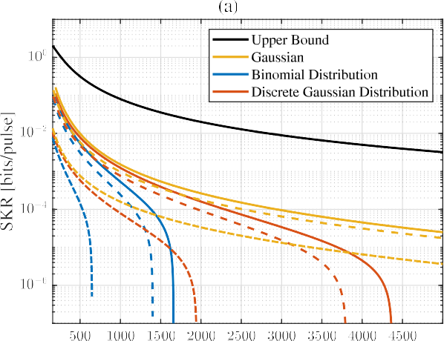
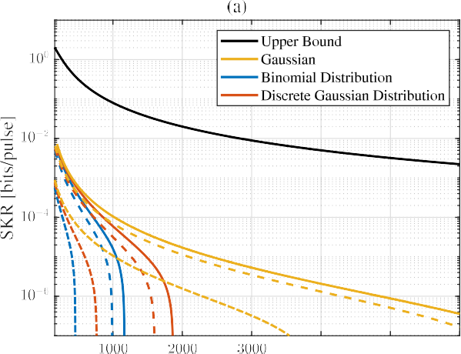

Fig. 5. Asymptotic limit SKRs as a function of satellite altitude for
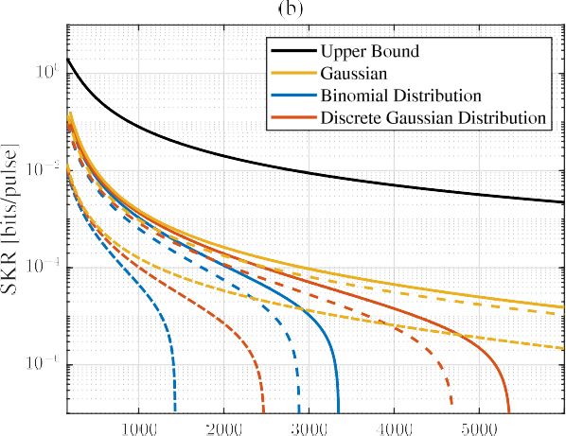
(a) 64-QAM and (b) 256-QAM DM-CVQKD in relation to GM-CVQKD in bad atmospheric conditions. The solid lines indicate θ = 90◦, dashed lines indicate θ = 60◦, dash-dotted lines indicate θ = 30◦. Dr = 1 m, β = 90%.

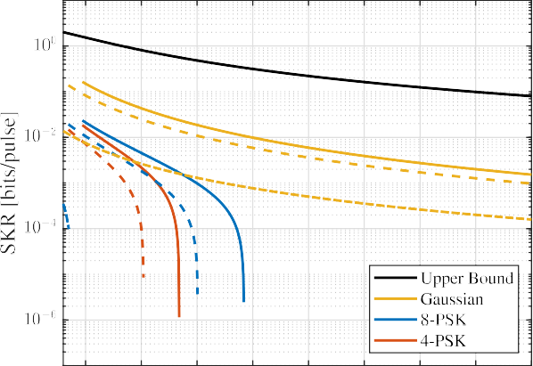
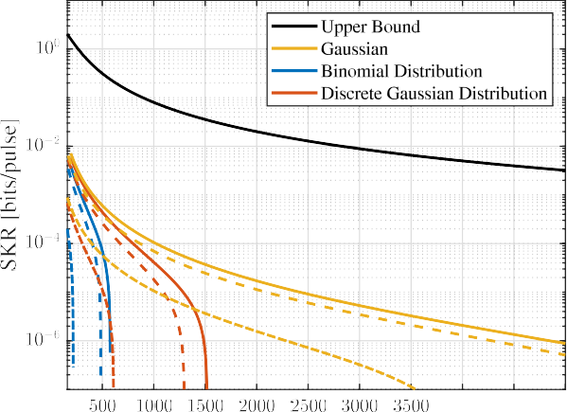

Fig. 4. Asymptotic limit SKRs as a function of satellite altitude for
(a) M -PSK, (b) 64-QAM, and (c) 256-QAM DM-CVQKD in relation to GM-CVQKD in good atmospheric conditions. The solid lines indicate θ = 90◦, dashed lines indicate θ = 60◦, dash-dotted lines indicate θ = 30◦. Dr = 1 m, β = 90%.

- Finite Size Limit SKRs of GM-CVQKD and DM-CVQKD
As security proofs for DM-CVQKD in the finite size limit are an active field of research [53], [54], [55], SKR analysis in the finite size limit was restricted to GM-CVQKD.
This analysis uses Equations 24-27. However, it is suspected that the relationship from asymptotic limit to finite size limit DM-CVQKD follows the same trend from asymptotic limit to finite size limit GM-CVQKD. No positive finite size limit SKRs are achieved in LEO GM-CVQKD in bad atmospheric conditions. This is evidence of the inability of CVQKD to operate in bad atmospheric conditions due to significant signal attenuation.
Figure 6 shows the finite SKRs in good atmospheric condi- tions for MD and MLC-MSD reconciliation. For a 1 m receiver aperture diameter, positive SKRs are restricted to a satellite orbit altitude below approximately 375 km and with larger elevation angles. Active propulsion is required to maintain this altitude, adding to the required complexities of a CVQKD LEO satellite. However, this situation can be ameliorated by increasing the receiver aperture diameter. In this case, the receiver aperture diameter was increased from 1 m to 2 m, increasing the satellite orbit altitude for which there is a positive SKR to a maximum of approximately 850 km and with lower elevation angles (Figure 6b). The results show that

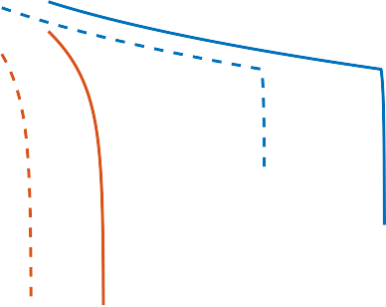
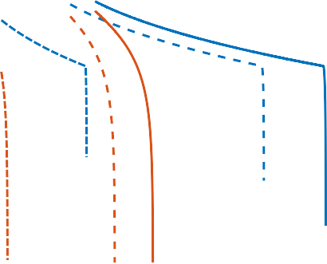
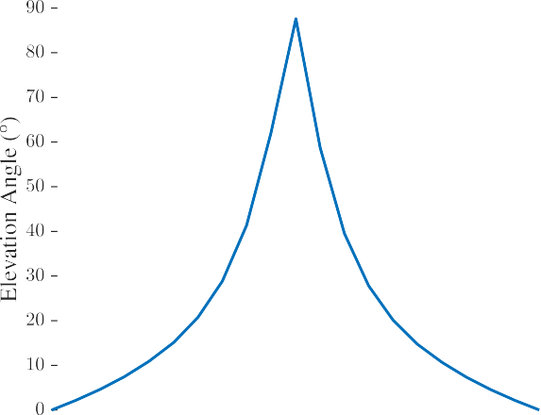
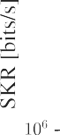
Fig. 7. Elevation for an ISS pass over Mt. John Observatory on 9th August 2022. The pass had a maximum elevation angle of 87.6◦.

Fig. 6. Finite size limit SKRs as a function of satellite altitude for a (a) 1m and (b) 2 m receiver aperture diameter GM-CVQKD downlink using MD and MLC-MSD reconciliation with homodyne detection. The solid lines indicate θ = 90◦, dashed lines indicate θ = 60◦, dash-dotted lines indicate θ = 30◦.

MD reconciliation outperforms MLC-MSD reconciliation by producing larger positive SKRs for larger link distances and lower elevation angles.
The finite size limit SKR calculation can also be presented as a function of elevation angle for a satellite at a certain orbit altitude. For this purpose, we assessed the orbit of the International Space Station (ISS), which has an average orbit altitude at zenith of 417.5 km, and studied a pass, shown in Figure 7, which occurred on 9th August 2022, over the Uni- versity of Canterbury’s Mt. John Observatory in New Zealand (Latitude = 43.9853○, Longitude = 170.4641○, Altitude = 1.029 km). The pass had a duration of 663 s with a maximum elevation angle of 87.6○. The calculations were made using the same link parameter values as in Table III with a receiver diameter aperture, D_{r}, of 2 m and OGS altitude, L_{geo}, of 1.029 km. A practical limitation to be noted is that a LEO satellite pass with large elevation angles may go through the keyhole of an observatory. In this situation, the satellite cannot be tracked.
—

Fig. 8. SKR for ISS pass over Mt. John Observatory with maximum elevation angle 87.6◦. Dr = 2 m. Homodyne detection. Lgeo = 1.029 km.

The SKR was calculated assuming good atmospheric con- ditions for the ISS pass (Figure 8). The results show that finite size limit GM-CVQKD with MD reconciliation outperforms MLC-MSD reconciliation by producing larger positive SKRs and at lower elevation angles.
Multiplying the calculated SKR by the time that the ISS is at a certain elevation angle produces the total number of bits of the secret key. The elevation angle has been discretised with a resolution of 1○ in Figure 7 to determine the temporal position of the ISS. The secret key has:
- 1.235 Gbit for GM-CVQKD with MD reconciliation,
- 385 Mbit for GM-CVQKD with MLC-MSD reconciliation.

- SKR Trends From Parameter Variation Analysis
A sensitivity analysis of the parameters leads to the following observed trends:
  - Increasing the laser repetition rate increases the finite size limit SKR.

  - Decreasing the value for allowable information for Eve in the finite size limit (δn_{privacy}) increases the SKR for a given link distance. This implies that there is greater accuracy in the estimated amount of information Eve has intercepted (Holevo information).
  - Increasing the transmitter and receiver aperture diameter as well as the transmitter and receiver optics efficiencies increases the maximum link distance and therefore satel- lite orbit altitude. This increase results from the decrease in losses during state preparation and measurement.
  - Decreasing the pointing loss increases the maximum link distance and therefore satellite orbit altitude. This requires a more accurate APT system as well as less beam wandering between Alice and Bob.
  - Increasing the OGS elevation increases the maximum link distance and therefore satellite orbit altitude for which a positive SKR is possible. This results from the decrease in attenuation from a decrease in link distance and effective atmosphere thickness as Bob is effectively closer to Alice.
  - Operating in good atmospheric conditions where there is greater visibility and a smaller refractive index struc- ture parameter increases the maximum link distance and therefore satellite orbit altitude. This results from the decrease in attenuation due to less atmospheric scattering and turbulence.
  - Protocols with a larger number of coherent states lead to larger SKRs.
- Discussion
The performance of recent MD and MLC-MSD recon- ciliation methods have been applied to GM-CVQKD in a satellite-to-ground context. It should be noted that the com- plexities of these reconciliation methods differ leading to different real-time decoding rates, and consequently, differ- ent times taken for real-time secret key generation between a satellite and OGS; the computational overhead of which would be more of a burden on the satellite. This stems from latency in data post-processing during the classical informa- tion reconciliation step in QKD. In combination with power consumption and heat dissipation in the satellite hardware, these practical elements would lead to a decrease in the achievable SKR. A practical solution to this would be to design an appropriate thermal management system on the satellite which would keep the satellite hardware to an appropriate low temperature to mitigate the negative effects of heating [56]. To solve power consumption and latency issues, the use of appropriate field-programmable gate arrays on the satellite for data post-processing would lead to relatively lower power consumption and high throughput by using their parallel computational ability [57]. Overall, a CVQKD satellite would need to be designed and engineered based on the desired SKRs during CVQKD. An alternative solution would be to perform information reconciliation offline and after the distribution of the secret key. Given that a LEO satellite pass is typically in the order of a few minutes, this is a promising solution for satellite-to-ground based QKD where the final secret key (after post-processing) is generated some time after the initial trans- mission, over multiple passes of the satellite over the OGS.
High turbulence in the atmosphere causes beam wandering during transmission between a satellite and an OGS. This may result in a large beam angle-of-arrival on the receiver aperture of the OGS, causing non-ideal coupling to fibre as the beam may not be focused on the fibre, and therefore this can introduce a probabilistic interruption in communication between the satellite and OGS. The details of this phenomena have previously been published [25], and it is similarly related to the probability threshold, p_{thr}, in Equation 31 which is the probability that the received power is below the minimum required power to register a signal, therefore causing an interruption in communication and a substantial decrease in achievable SKRs.
The loss-limited SKR upper bound was compared with achievable asymptotic limit SKRs for GM-CVQKD and DM-CVQKD. It should be noted that a thermal-loss SKR upper bound, which incorporates noise components, and a thermal-loss SKR lower bound have also been determined in References [29] and [30]. However, as shown in Figure 3 in Ref. [29], the loss-limited SKR upper bound and the thermal-loss SKR upper and lower bounds are identical in LEO and low MEO altitudes. For this reason, the loss-limited SKR upper bound was used for comparison. Furthermore, the bounds are for ideal systems. In contrast, the SKRs calculated for GM-CVQKD and DM-CVQKD consider parameters found in practical satellite-to-ground CVQKD such as the reconcili- ation efficiency as well as the modulation variance, which lead to lower but more practical achievable SKRs.

- Conclusion
In this work, a feasibility study for practical satellite- to-ground CVQKD with a focus on comparing existing GM-CVQKD and DM-CVQKD protocols with the application of the performance of recent reconciliation methods is presented. The results show that GM-CVQKD outperforms both the M -PSK and M -QAM DM-CVQKD protocols in the asymptotic limit. However, the M -QAM protocol outperforms the M -PSK protocol and is capable of producing positive SKRs in both LEO and low MEO. In the finite size limit, MD reconciliation outperforms MLC-MSD reconciliation by producing larger positive SKRs in GM-CVQKD for larger link distances and lower elevation angles. The physical implemen- tations of both GM-CVQKD and DM-CVQKD as well as the processes for MD and MLC-MSD reconciliation have not been considered. These should be investigated further for future satellite-to-ground and long distance CVQKD operation.

References
- H.-K. Lo and H. F. Chau, “Unconditional security of quantum key distribution over arbitrarily long distances,” Science, vol. 283, no. 5410,
pp. 2050–2056, Mar. 1999.
- J. Yin et al., “Entanglement-based secure quantum cryptography over 1,120 kilometres,” Nature, vol. 582, no. 7813, pp. 501–505, Jun. 2020.
- F. Laudenbach et al., “Continuous-variable quantum key distribution with Gaussian modulation—The theory of practical implementations,” Adv. Quantum Technol., vol. 1, no. 1, Aug. 2018, Art. no. 1800011.
- R. García-Patrón and N. J. Cerf, “Unconditional optimality of Gaussian attacks against continuous-variable quantum key distribution,” Phys. Rev. Lett., vol. 97, no. 19, Nov. 2006, Art. no. 190503.

- E. Villaseñor, R. Malaney, K. A. Mudge, and K. J. Grant, “Atmospheric effects on satellite-to-ground quantum key distribution using coherent states,” in Proc. IEEE Global Commun. Conf., Dec. 2020, pp. 1–6.
- S. P. Kish, P. Gleeson, P. Koy Lam, and S. M. Assad, “Comparison of discrete variable and continuous variable quantum key distribu- tion protocols with phase noise in the thermal-loss channel,” 2022, arXiv:2206.13724.
- S. Ren, S. Yang, A. Wonfor, R. Penty, and I. White, “Experimental demonstration of high key rate and low complexity CVQKD system with local local oscillator,” in Proc. Opt. Fiber Commun. Conf. Exhib. (OFC), Mar. 2020, pp. 1–3.
- D. Huang, P. Huang, D. Lin, and G. Zeng, “Long-distance continuous- variable quantum key distribution by controlling excess noise,” Sci. Rep., vol. 6, no. 1, p. 19201, Jan. 2016.
- Z. Qu and I. B. Djordjevic, “High-speed free-space optical continuous variable-quantum key distribution based on Kramers–Kronig scheme,” IEEE Photon. J., vol. 10, no. 6, pp. 1–7, Dec. 2018.
- A. Mecozzi, C. Antonelli, and M. Shtaif, “Kramers–Kronig coherent receiver,” Optica, vol. 3, no. 11, pp. 1220–1227, 2016.
- Z. Qu and I. B. Djordjevic, “High-speed free-space optical continuous- variable quantum key distribution enabled by three-dimensional multi- plexing,” Opt. Exp., vol. 25, no. 7, p. 7919, 2017.
- M. Zhang, P. Huang, P. Wang, S. Wei, and G. Zeng, “Experimental free-space continuous-variable quantum key distribution with thermal source,” Opt. Lett., vol. 48, no. 5, pp. 1184–1187, 2023.
- B. Heim et al., “Atmospheric continuous-variable quantum communica- tion,” New J. Phys., vol. 16, no. 11, Nov. 2014, Art. no. 113018.
- S.-Y. Shen, M.-W. Dai, X.-T. Zheng, Q.-Y. Sun, G.-C. Guo, and
Z.-F. Han, “Free-space continuous-variable quantum key distribution of unidimensional Gaussian modulation using polarized coherent states in an urban environment,” Phys. Rev. A, Gen. Phys., vol. 100, no. 1, Jul. 2019, Art. no. 012325.
- A. Leverrier and P. Grangier, “Unconditional security proof of long-distance continuous-variable quantum key distribution with dis- crete modulation,” Phys. Rev. Lett., vol. 102, no. 18, May 2009, Art. no. 180504.
- F. Grosshans and P. Grangier, “Continuous variable quantum cryptogra- phy using coherent states,” Phys. Rev. Lett., vol. 88, no. 5, Jan. 2002, Art. no. 057902.
- Y. Shen, H. Zou, L. Tian, P. Chen, and J. Yuan, “Experimental study on discretely modulated continuous-variable quantum key distribution,” Phys. Rev. A, Gen. Phys., vol. 82, no. 2, Aug. 2010, Art. no. 022317.
- W. Zhao, R. Shi, Y. Feng, and D. Huang, “Unidimensional continuous- variable quantum key distribution with discrete modulation,” Phys. Lett. A, vol. 384, no. 2, Jan. 2020, Art. no. 126061.
- H. Zhang, J. Fang, and G. He, “Improving the performance of the four-state continuous-variable quantum key distribution by using optical amplifiers,” Phys. Rev. A, Gen. Phys., vol. 86, no. 2, Aug. 2012, Art. no. 022338.
- A. Becir, F. El-Orany, and M. Wahiddin, “Continuous-variable quantum key distribution protocols with eight-state discrete modulation,” Int. J. Quantum Inf., vol. 10, no. 1, 2012, Art. no. 1250004.
- M. Sayat et al., “LEO-to-ground Gaussian modulated continuous vari- able quantum key distribution,” in Proc. Int. Astron. Congr., Sep. 2022.
- N. Hosseinidehaj, Z. Babar, R. Malaney, S. X. Ng, and L. Hanzo, “Satellite-based continuous-variable quantum communications: State-of- the-art and a predictive outlook,” IEEE Commun. Surveys Tuts., vol. 21, no. 1, pp. 881–919, 1st Quart., 2019.
- Y. Guo et al., “Channel-parameter estimation for satellite-to-submarine continuous-variable quantum key distribution,” Phys. Rev. A, Gen. Phys., vol. 97, no. 5, May 2018, Art. no. 052326.
- D. Dequal et al., “Feasibility of satellite-to-ground continuous-variable quantum key distribution,” NPJ Quantum Inf., vol. 7, no. 1, p. 3, Jan. 2021.
- S. Wang, P. Huang, T. Wang, and G. Zeng, “Atmospheric effects on continuous-variable quantum key distribution,” New J. Phys., vol. 20, no. 8, Aug. 2018, Art. no. 083037.
- I. B. Djordjevic, “Optimized-eight-state CV-QKD protocol outperform- ing Gaussian modulation based protocols,” IEEE Photon. J., vol. 11, no. 4, pp. 1–10, Aug. 2019.
- T.-L. Wang, I. B. Djordjevic, and J. Nagel, “Laser beam propagation effects on secure key rates for satellite-to-ground discrete modulation CV-QKD,” Appl. Opt., vol. 58, no. 29, pp. 8061–8068, 2019.
- A. Denys, P. Brown, and A. Leverrier, “Explicit asymptotic secret key rate of continuous-variable quantum key distribution with an arbitrary modulation,” Quantum, vol. 5, p. 540, Sep. 2021.
- S. Pirandola, “Satellite quantum communications: Fundamental bounds and practical security,” Phys. Rev. Res., vol. 3, no. 2, May 2021, Art. no. 023130.
- S. Pirandola, “Limits and security of free-space quantum communica- tions,” Phys. Rev. Res., vol. 3, no. 1, Mar. 2021, Art. no. 013279.
- S. P. Kish, E. Villaseñor, R. Malaney, K. A. Mudge, and K. J. Grant, “Feasibility assessment for practical continuous variable quantum key distribution over the satellite-to-Earth channel,” Quantum Eng., vol. 2, no. 3, p. e50, Sep. 2020.
- H. Mani, T. Gehring, P. Grabenweger, B. Ömer, C. Pacher, and
U. L. Andersen, “Multiedge-type low-density parity-check codes for continuous-variable quantum key distribution,” Phys. Rev. A, Gen. Phys., vol. 103, no. 6, Jun. 2021, Art. no. 062419.
- S. J. Johnson, A. M. Lance, L. Ong, M. Shirvanimoghaddam,
T. C. Ralph, and T. Symul, “On the problem of non-zero word error rates for fixed-rate error correction codes in continuous variable quan- tum key distribution,” New J. Phys., vol. 19, no. 2, Feb. 2017, Art. no. 023003.
- S. Jeong, H. Jung, and J. Ha, “Rate-compatible multi-edge type low- density parity-check code ensembles for continuous-variable quantum key distribution systems,” NPJ Quantum Inf., vol. 8, no. 1, p. 6, Jan. 2022.
- S. Ghorai, E. Diamanti, and A. Leverrier, “Composable security of two-way continuous-variable quantum key distribution without active symmetrization,” Phys. Rev. A, Gen. Phys., vol. 99, no. 1, Jan. 2019, Art. no. 012311.
- N. Hosseinidehaj, N. Walk, and T. C. Ralph, “Composable finite- size effects in free-space continuous-variable quantum-key-distribution systems,” Phys. Rev. A, Gen. Phys., vol. 103, no. 1, Jan. 2021, Art. no. 012605.
- N. Hosseinidehaj, A. M. Lance, T. Symul, N. Walk, and T. C. Ralph, “Finite-size effects in continuous-variable quantum key distribution with Gaussian postselection,” Phys. Rev. A, Gen. Phys., vol. 101, no. 5, May 2020, Art. no. 052335.
- A. Leverrier, “Composable security proof for continuous-variable quan- tum key distribution with coherent states,” Phys. Rev. Lett., vol. 114, no. 7, Feb. 2015, Art. no. 070501.
- C. Lupo, C. Ottaviani, P. Papanastasiou, and S. Pirandola, “Continuous- variable measurement-device-independent quantum key distribution: Composable security against coherent attacks,” Phys. Rev. A, Gen. Phys., vol. 97, no. 5, May 2018, Art. no. 052327.
- H. Wang et al., “25 MHz repetition rate pilot-tone-assisted Gaussian- modulated continuous-variable quantum key distribution with a local local oscillator,” in Proc. 19th Int. Conf. Opt. Commun. Netw. (ICOCN), Aug. 2021, pp. 1–3.
- T. Hirano et al., “Implementation of continuous-variable quantum key distribution with discrete modulation,” Quantum Sci. Technol., vol. 2, no. 2, Jun. 2017, Art. no. 024010.
- D. Huang, J. Fang, C. Wang, P. Huang, and G.-H. Zeng, “A 300- MHz bandwidth balanced homodyne detector for continuous variable quantum key distribution,” Chin. Phys. Lett., vol. 30, no. 11, Nov. 2013, Art. no. 114209.
- S. Ren, S. Yang, A. Wonfor, I. White, and R. Penty, “Demonstration of high-speed and low-complexity continuous variable quantum key distribution system with local local oscillator,” Sci. Rep., vol. 11, no. 1,
p. 9454, May 2021.
- F. H. Bennet, K. Ferguson, K. Grant, E. Kruzins, N. Rattenbury, and S. Schediwy, “An Australia/New Zealand optical communications ground station network for next generation satellite communica- tions,” in Proc. 32nd Free-Space Laser Commun., H. Hemmati and
- M. Boroson, Eds., vol. 11272. Bellingham, WA, USA: SPIE, Mar. 2020, pp. 1–7.
- S. Muhammad, P. Kohldorfer, and E. Leitgeb, “Channel modeling for terrestrial free space optical links,” in Proc. 7th Int. Conf. Transp. Opt. Netw., vol. 1, 2005, pp. 407–410.
- C. Liorni, H. Kampermann, and D. Bruß, “Satellite-based links for quantum key distribution: Beam effects and weather dependence,” New
J. Phys., vol. 21, no. 9, Sep. 2019, Art. no. 093055.
- Z. Zuo, Y. Wang, D. Huang, and Y. Guo, “Atmospheric effects on satellite-mediated continuous-variable quantum key distribution,”
  - Phys. A, Math. Theor., vol. 53, no. 46, Nov. 2020, Art. no. 465302.

- M. Aspelmeyer, T. Jennewein, M. Pfennigbauer, W. R. Leeb, and
A. Zeilinger, “Long-distance quantum communication with entangled photons using satellites,” IEEE J. Sel. Topics Quantum Electron., vol. 9, no. 6, pp. 1541–1551, Nov. 2003.
- I. I. Kim, B. McArthur, and E. J. Korevaar, “Comparison of laser beam propagation at 785 nm and 1550 nm in fog and haze for optical wireless communications,” in Optical Wireless Communications III, vol. 4214. Bellingham, WA, USA: SPIE, 2001, pp. 26–37.
- M. Grabner and V. Kvicera, “Fog attenuation dependence on atmo- spheric visibility at two wavelengths for FSO link planning,” in Proc. Loughborough Antennas Propagat. Conf., 2010, pp. 193–196.
- D. Giggenbach, “Fading-loss assessment in atmospheric free-space optical communication links with on-off keying,” Opt. Eng., vol. 47, no. 4, Apr. 2008, Art. no. 046001.
- L. C. Andrews et al., “Near-ground vertical profile of refractive-index fluctuations,” in Atmospheric Propagation VI, L. M. W. Thomas and
G. C. Gilbreath, Eds., vol. 7324. Bellingham, WA, USA: SPIE, 2009,
pp. 11–22.
- T. Matsuura, K. Maeda, T. Sasaki, and M. Koashi, “Finite-size security of continuous-variable quantum key distribution with digital signal processing,” Nature Commun., vol. 12, no. 1, p. 252, Jan. 2021.
- S. Yamano, T. Matsuura, Y. Kuramochi, T. Sasaki, and M. Koashi, “Finite-size security proof of binary-modulation continuous-variable quantum key distribution using only heterodyne measurement,” 2022, arXiv:2208.11983.
- F. Kanitschar, I. George, J. Lin, T. Upadhyaya, and N. Lütkenhaus, “Finite-size security for discrete-modulated continuous-variable quan- tum key distribution protocols,” 2023, arXiv:2301.08686.
- R. Bedington, J. M. Arrazola, and A. Ling, “Progress in satellite quantum key distribution,” NPJ Quantum Inf., vol. 3, no. 1, p. 30, Aug. 2017.
- S. Yang et al., “Information reconciliation of continuous-variables quan- tum key distribution: Principles, implementations and applications,” EPJ Quantum Technol., vol. 10, no. 1, p. 40, Dec. 2023.


Mikhael T. Sayat received the B.E. (Hons.) degree in mechatronics engineering and the B.Sc. degree in physics from The University of Auckland, New Zealand, in 2021, where he is currently pursu- ing the Ph.D. degree. His research interests include quantum key distribution, quantum communications, quantum networks, and space-based quantum tech- nologies. He was a recipient of the 2022 New Zealand Space Scholarship to Intern at NASA JPL.
Syed M. Assad received the B.Sc. degree in physics and computational science from the National Uni- versity of Singapore and the joint Ph.D. degree in realization of harmonic entanglement between a light beam and its second harmonic and theoreti- cal proofs of security for quantum key distribution protocols from the National University of Singapore and The Australian National University in 2011. He was with the National University of Singapore as a Teaching Assistant and the Centre for Quantum Technologies as a Research Assistant. He has been
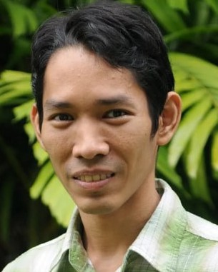
with the Quantum Optics Group, The Australian National University, since 2011, where he is currently leading the Secure Communications Team. He is also a Principal Scientist with A*STAR. He is a member of the Centre of Excellence for Quantum Computation and Communication Technology.

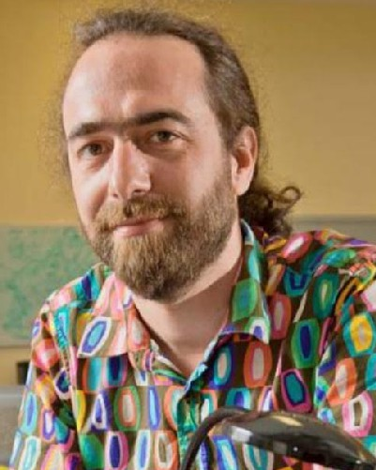
Thomas Symul received the degree from École Nationale Supérieure des Télécommunications of Paris in 1998 and the Ph.D. degree in physics from the University of Paris VI in 2001. He is cur- rently the Quantum Research and Development Lead with QuintessenceLabs and one of its scientific co- founders. He has published over 50 articles during his career, including in prestigious journals, such as Nature and Physical Review Letters. He received the Eureka Prize for Scientific Research in 2006 and the AIP Alan Walsh Medal for service to the industry in 2014.

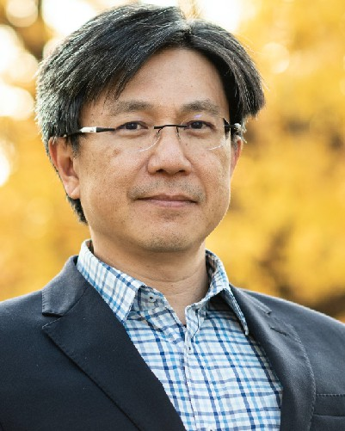
Ping Koy Lam received the B.Sc. degree in mathematics and physics from The University of Auckland and the M.Sc. degree in theoretical physics and the Ph.D. degree in experimental physics from The Australian National University (ANU). He was a Process Engineer with Sony (audio electronics) and Hewlett-Packard (semiconductor LED) for three years prior to his post-graduate studies with ANU. He is currently the Chief Quantum Scientist with the Agency for Science, Technology, and Research (A*STAR), Singapore. He has authored around
260 articles on his research in quantum physics. He was a recipient of the Australian Institute of Physics Bragg Medal and the Australian National University Crawford Prize for his Ph.D. dissertation in 1999. He received the British Council Eureka Prize for inspiring science in 2003 and the University of New South Wales Eureka Prize for innovative research in 2006.


Biveen Shajilal received the Ph.D. degree in quantum optics from The Australian National Uni- versity in 2023. He was with the ARC Centre of Excellence for Quantum Computation and Commu- nication Technology. He is currently a Scientist with the Agency for Science, Research and Technology, Singapore. His research interests include quantum optics and quantum information.

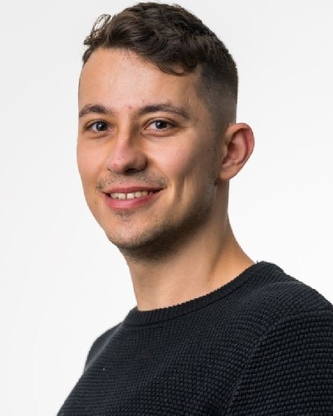
Sebastian P. Kish received the Ph.D. degree in physics from The University of Queensland, Australia, in 2019. He is currently a Research Scien- tist of quantum key distribution with CSIRO Data61, Marsfield. Previously, he was a Post-Doctoral Fel- low with The Australian National University and a Research Associate with UNSW. His research interests include quantum communications, quantum information, and quantum entanglement.

Nicholas J. Rattenbury received the Ph.D. degree in physics from The University of Auckland, New Zealand, in 2004. His research interests include free-space optical communications, astrodynamics, and time-domain astrophysics.

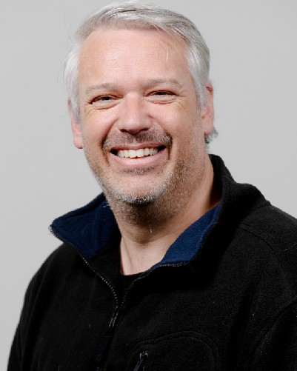
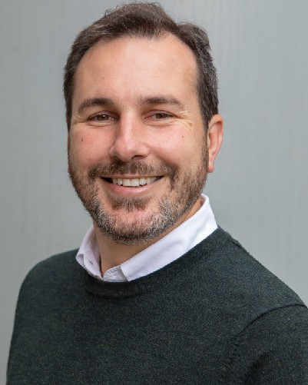
John E. Cater received the B.E. degree (Hons.) in mechanical engineering from The University of Auckland, New Zealand, in 1997, and the Ph.D. degree from Monash University, Australia, in 2003. He leads research in aerospace engineering. His research interests include electric propulsion for small satellites and modeling of thermal protection systems for reentry of spacecraft.

